**#. Subject: Deniliquin Local Environmental Plan 2013 – Planning Proposal No 8**

**From: Manager Economic and Business Development**

**John Harvie**

**Prepared By: Manager Environmental Services**

**Julie Rogers**

**Recommendation:**

**Division**

In accordance with the requirements of the Local Government Act, it is necessary for Council to call a division when voting on any resolution that involves making a planning decision.

That Council:

a Prepare a planning proposal to amend the Deniliquin Local Environmental Plan 2013 in accordance with section 55(1) of the Environmental Planning and Assessment Act 1979 to rezone Lots 2, 3 and 4 DP286006 Barham Road, Deniliquin from RU1 Primary Production to IN1 General Industrial.

b Forward the planning proposal to the Minister for Planning and Infrastructure in accordance with section 56(1) of the Environmental Planning and Assessment Act 1979.

c Request that the local planning making functions in relation to this planning proposal be delegated to Council.

**Background**

Council has received a request from the owner of Lots 2, 3, and 4 DP286006 Barham Road from RU1 Primary Production to IN1 General Industrial under the Deniliquin Local Environmental Plan 2013. Attachment 1 is the request from the land owner. Figure 1 shows the location of the site.

The subject site is located on Barham Road and Leetham Road and is held in three titles. The subject site also has frontage to the railway line. The site has a total area of 66.5ha with each lot having the following land area:

|  |  |
| --- | --- |
| **Lot** | **Land Area** |
| Lot 2 DP286006 | 27.25ha |
| Lot 3 DP286006 | 19.49ha |
| Lot 4 DP286006 | 19.75ha |

The site is vacant and used for agriculture ie grazing of livestock. There is no significant vegetation on the site. The site is within the vicinity of the recently approved ethanol plant and Council’s effluent dam. The site adjoins land zoned IN1 General Industrial, RU1 Primary Production and SP2 Infrastructure and is surrounded by a variety of land uses including agriculture, dwellings, industrial uses and infrastructure and is also within the vicinity of the site for the recently approved ethanol plant.

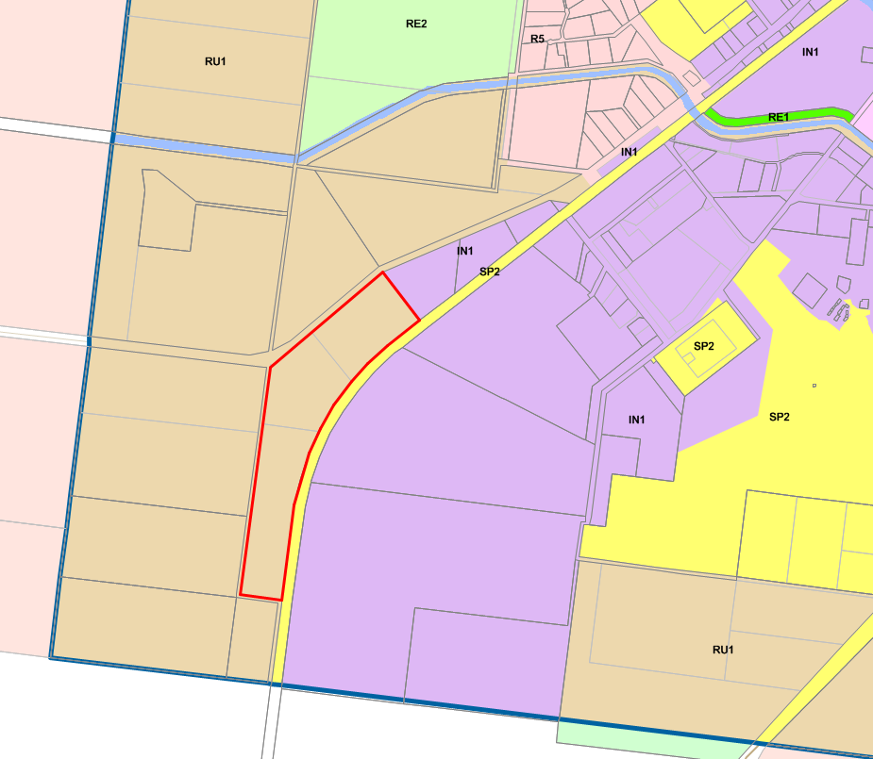

**Figure 1 Location of subject site**

A planning proposal (Attachment 2) has been prepared to support the rezoning.

Existing industrial land supply is adequate however is not market ready due to a lack of services, inadequate road access, size of lots and land bankers. The planning proposal supports the rezoning of the land for the following reasons:

* Land is located adjoining the existing IN1 General Industrial zone;
* Two of the three lots have frontage to a regional road which is a B double and road train route;
* Land is within the vicinity of water and sewer infrastructure; and
* Size of holding.

**Proposed Changes to the LEP 2013**

The planning controls under LEP 2013 for the subject site will be amended by changing the zone to IN1 General Industrial and removing the minimum lot size provisions.

**Planning Proposal**

The planning proposal has been prepared in accordance with ‘*A Guide to Preparing Planning Proposal*’ (NSW Planning Infrastructure, 2016) and is Attachment 2.

**Public Participation and Government Agency Consultation**

In accordance with section 57 of the Environmental Planning and Assessment Act, it is proposed to exhibit the planning proposal for 14 days in the local media and on Council’s website. The adjoining property owners will be notified.

**Strategic Implications:**

An amendment to LEP 2013 is required to achieve the objectives of the planning proposal.

**Budgetary Implications:**

Nil.

**Policy Implications:**

Nil.

**Legislative Implications:**

To amend the LEP 2013 a planning proposal must be prepared in accordance with section 55 of the Environmental Planning and Assessment Act (the Act). This planning proposal is then forwarded to the Department of Planning in accordance with section 56(1) of the Act and a gateway determination is then issued in accordance with section 56(2).

Council will request that the plan making delegations functions be delegated to Council due to the minor nature of the planning proposal. A copy of the request for the delegation of plan making functions to Council is attached.

**Risk Assessment:**

***What can happen?***

Land can be rezoned to allow for industrial development.

***How can it happen?***

By preparing a planning proposal.

***What are the consequences of the event happening?***

LEP 2013 would be amended.

***What is the likelihood of the event happening?***

High.

***Adequacy of existing controls?***

An amendment is required to achieve the objectives of the planning proposal.

***Treatment options to mitigate the risk?***

Prepare a planning proposal.

**Conclusion:**

Council should submit the planning proposal to the Department for a gateway determination.

**Attachments:**

1. Request from landowner – 1 page
2. Planning Proposal – 13 pages
3. Evaluation Criteria for the Delegation of Plan Making Functions – 4 pages